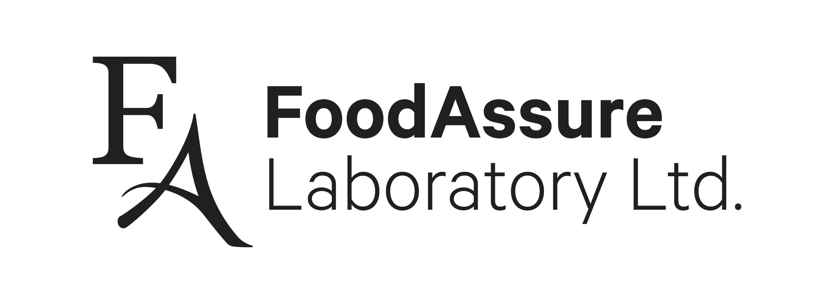

1
96
0
Pandora St.

Vancouver, BC

V5L
0
C
7

604
-
251
-
9588

info@foodassure.com

Chain of Custody

Date submitted: {{date_long}} PO#: {{po_number}}

Customer Info
Company Name/Requested by: Cascadia Seaweed Corp.

Address: C 9774 Third St, Sidney, BC V8L 3A4

Phone: {{customer_phone}} Email: {{customer_email_1}}
{{customer_email_2}} {{customer_email_3}} {{customer_email_4}} {{customer_email_5}}

Sample Description  (How you would like us to refer to your sample on your report)¹ | Tests Requested²
Please refer to the attached spreadsheet for sample description, sample ID, and tests required for each sample.  Note: Treat identically labeled tubes as one sample and perform a single analysis. | {{analysis.name}}

Samples received by: ____________
Notes: {{notes}}
Send results to all emails provided
- Certificate of Analysis will include this section, as written. Please include any relevant information desired for CoA, e.g. prod date, lot #, etc.
- If analysis is required according to a specific methodology, please note under this section.
All customer information obtained by FoodAssure Laboratory Ltd. shall be considered proprietary to the customer, will not be made public, or shared in any way outside the organization. Any information which the customer has not itself made public, will be regarded as confidential and subject to legally enforceable commitments by FoodAssure and its staff. When FoodAssure is required by law or authorized by contractual agreements to release confidential information, the customer concerned shall, unless prohibited by law, be notified in writing of the information provided.

FAF-11 Version 5.1 December 2024 Approved by Anna Piesik page 1 of 1

